The Summary of Benefits and Coverage (SBC) document will help you choose a health plan. The SBC shows you how you and the plan would share the cost for covered health care services. NOTE: Information about the cost of this plan (called the premium) will be provided separately. This is only a summary. For more information about your coverage, or to get a copy of the complete terms of coverage, visit bsca.com/policies or call 1-800-287-1442. For general definitions of common terms, such as allowed amount, balance billing, coinsurance, copayment, deductible, provider, or other underlined terms see the Glossary. You can view the Glossary at healthcare.gov/sbc-glossary or call 1-866-444-3272 to request a copy.

Important Questions | Answers | Why This Matters:
What is the overall deductible? | $1,500 per individual / $3,000 per family for participating providers and non-participating providers. | Generally, you must pay all of the costs from providers up to the deductible amount before this plan begins to pay. If you have other family members on the plan each family member must meet their own individual deductible until the total amount of deductible expenses paid by all family members meets the overall family deductible.
Are there services covered before you meet your deductible? | Yes. Preventive care and services listed in your complete terms of coverage. | This plan covers some items and services even if you haven’t yet met the deductible amount. But a copayment or coinsurance may apply. For example, this plan covers certain preventive services without cost-sharing and before you meet your deductible. See a list of covered preventive services at healthcare.gov/coverage/preventive-care-benefits.
Are there other deductibles for specific services? | No. | You don’t have to meet deductibles for specific services.
What is the out-of-pocket limit for this plan? | $6,350 per individual / $12,700 per family for participating providers; $12,700 per individual / $25,400 per family for non-participating providers. | The out-of-pocket limit is the most you could pay in a year for covered services. If you have other family members in this plan, they have to meet their own out-of-pocket limits until the overall family out-of-pocket limit has been met.
What is not included in the out-of-pocket limit? | Copayments for certain services, premiums, balance-billing charges, and health care this plan doesn’t cover. | Even though you pay these expenses, they don’t count toward the out-of-pocket limit.
Will you pay less if you use a network provider? | Yes. See blueshieldca.com/fad or call 1-800-287-1442 for a list of network providers. | This plan uses a provider network. You will pay less if you use a provider in the plan’s network. You will pay the most if you use an out-of-network provider, and you might receive a bill from a provider for the difference between the provider’s charge and what your plan pays (balance billing). Be aware, your network provider might use an out-of-network provider for some services (such as lab work). Check with your provider before you get services.
Do you need a referral to see a specialist? | No. | You can see the specialist you choose without a referral.

All copayment and coinsurance costs shown in this chart are after your deductible has been met, if a deductible applies.
Common Medical Event | Services You May Need | What You Will Pay |  | Limitations, Exceptions, & Other Important Information
 |  | Participating Provider  (You will pay the least) | Non-Participating Provider  (You will pay the most)
If you visit a health care provider's office or clinic | Primary care visit to treat an injury or illness | $40/visit; deductible does not apply | 50% coinsurance | ----------------------None-----------------------
 | Specialist visit | $50/visit; deductible does not apply | 50% coinsurance
 | Preventive care/screening /immunization | No Charge; deductible does not apply | 50% coinsurance | You may have to pay for services that aren’t preventive. Ask your provider if the services needed are preventive. Then check what your plan will pay for.
If you have a test | Diagnostic test (x-ray, blood work) | Lab & Path: 30% coinsurance; deductible does not apply  X-Ray & Imaging: No Charge; deductible does not apply  Other Diagnostic Examination: 30% coinsurance; deductible does not apply | Lab & Path: 50% coinsurance  X-Ray & Imaging: 50% coinsurance  Other Diagnostic Examination: 50% coinsurance | The services listed are at a freestanding location.
 | Imaging (CT/PET scans, MRIs) | Independent (non-hospital owned) Radiology Center: No Charge; deductible does not apply  Outpatient Hospital: 30% coinsurance; deductible does not apply | Outpatient Radiology Center: 50% coinsurance  Outpatient Hospital: 50% coinsurance | Preauthorization is required. Failure to obtain preauthorization may result in non-payment of benefits.
If you need drugs to treat your illness or condition | Tier 1 | Retail: Not Covered  Mail Service: Not Covered | Retail: Not Covered  Mail Service: Not Covered | Your Prescription Drug Coverage is covered by Express Scripts. For more information, please call 1-866-321-9650.
 | Tier 2 | Retail: Not Covered  Mail Service: Not Covered | Retail: Not Covered  Mail Service: Not Covered
 | Tier 3 | Retail: Not Covered  Mail Service: Not Covered | Retail: Not Covered  Mail Service: Not Covered
 | Tier 4 | Retail and Network Specialty Pharmacies: Not Covered  Mail Service: Not Covered | Retail: Not Covered  Mail Service: Not Covered
If you have outpatient surgery | Facility fee (e.g., ambulatory surgery center) | Ambulatory Surgery Center: 15% coinsurance  Outpatient Hospital: $125/surgery + 30% coinsurance | Ambulatory Surgery Center: 50% coinsurance  Outpatient Hospital: $125/surgery + 50% coinsurance | ----------------------None-----------------------
 | Physician/surgeon fees | 30% coinsurance | 50% coinsurance
If you need immediate medical attention | Emergency room care | Facility Fee: $250/visit + 30% coinsurance  Physician Fee: 30% coinsurance | Facility Fee: $250/visit + 30% coinsurance  Physician Fee: 30% coinsurance | ----------------------None-----------------------
 | Emergency medical transportation | 30% coinsurance | 30% coinsurance | This payment is for emergency or authorized transport.
 | Urgent care | $40/visit; deductible does not apply | 50% coinsurance | ----------------------None-----------------------
If you have a hospital stay | Facility fee (e.g., hospital room) | $250/admission + 30% coinsurance | $250/admission + 50% coinsurance | Preauthorization is required. Failure to obtain preauthorization may result in non-payment of benefits.
 | Physician/surgeon fees | 30% coinsurance | 50% coinsurance | ----------------------None-----------------------
If you need mental health, behavioral health, or substance abuse services | Outpatient services | Office Visit: $40/visit; deductible does not apply  Other Outpatient Services: 30% coinsurance  Partial Hospitalization: 30% coinsurance  Psychological Testing: 30% coinsurance; deductible does not apply | Office Visit: 50% coinsurance  Other Outpatient Services: 50% coinsurance  Partial Hospitalization: 50% coinsurance  Psychological Testing: 50% coinsurance | Preauthorization is required except for office visits and office-based opioid treatment. Failure to obtain preauthorization may result in non-payment of benefits.
 | Inpatient services | Physician Inpatient Services: 30% coinsurance  Hospital Services: $250/admission + 30% coinsurance  Residential Care: $250/admission + 30% coinsurance | Physician Inpatient Services: 50% coinsurance  Hospital Services: $250/admission + 50% coinsurance  Residential Care: $250/admission + 50% coinsurance | Preauthorization is required. Failure to obtain preauthorization may result in non-payment of benefits.
If you are pregnant | Office visits | 30% coinsurance | 50% coinsurance | ----------------------None-----------------------
 | Childbirth/delivery professional services | 30% coinsurance | 50% coinsurance
 | Childbirth/delivery facility services | $250/admission + 30% coinsurance | $250/admission + 50% coinsurance
If you need help recovering or have other special health needs | Home health care | 30% coinsurance | 50% coinsurance | Preauthorization is required. Failure to obtain preauthorization may result in non-payment of benefits. Coverage limited to 120 visits per member per Calendar Year.
 | Rehabilitation services | Office Visit: 30% coinsurance  Outpatient Hospital: 30% coinsurance | Office Visit: 50% coinsurance  Outpatient Hospital: 50% coinsurance | ----------------------None-----------------------
 | Habilitation services | Office Visit: 30% coinsurance  Outpatient Hospital: 30% coinsurance | Office Visit: 50% coinsurance  Outpatient Hospital: 50% coinsurance
 | Skilled nursing care | Freestanding SNF: 30% coinsurance  Hospital-based SNF: 30% coinsurance | Freestanding SNF: 30% coinsurance  Hospital-based SNF: 30% coinsurance | Preauthorization is required. Failure to obtain preauthorization may result in non-payment of benefits. Coverage limited to 365 days per member per benefit period.
 | Durable medical equipment | 30% coinsurance | 50% coinsurance | Preauthorization is required. Failure to obtain preauthorization may result in non-payment of benefits.
 | Hospice services | No Charge | No Charge | Preauthorization is required except for pre-hospice consultation. Failure to obtain preauthorization may result in non-payment of benefits.
If your child needs dental or eye care | Children's eye exam | Not Covered | Not Covered | ----------------------None-----------------------
 | Children's glasses | Not Covered | Not Covered
 | Children's dental check-up | Not Covered | Not Covered

Excluded Services & Other Covered Services:
Services Your Plan Generally Does NOT Cover (Check your policy or plan document for more information and a list of any other excluded services.)
- Chiropractic Care | - Hearing Aids | - Non-emergency care when traveling outside the U.S. | - Routine foot care
- Cosmetic surgery | - Infertility Treatment | - Private-duty nursing | - Weight loss programs
- Dental care (Adult) | - Long-term care | - Routine eye care (Adult)

Other Covered Services (Limitations may apply to these services. This isn't a complete list. Please see your plan document.)
- Acupuncture | - Bariatric surgery

Your Rights to Continue Coverage: There are agencies that can help if you want to continue your coverage after it ends. The contact information for those agencies is: Department of Health and Human Services, Center for Consumer Information and Insurance Oversight, at 1-877-267-2323 x61565 or cciio.cms.gov. Other coverage options may be available to you too, including buying individual insurance coverage through the Health Insurance Marketplace. For more information about the Marketplace, visit HealthCare.gov or call 1-800-318-2596.

Your Grievance and Appeals Rights: There are agencies that can help if you have a complaint against your plan for a denial of a claim. This complaint is called a grievance or appeal. For more information about your rights, look at the explanation of benefits you will receive for that medical claim. Your plan documents also provide complete information to submit a claim, appeal, or a grievance for any reason to your plan. For more information about your rights, this notice or assistance, contact: Blue Shield Customer Service at 1-800-287-1442 or the Department of Labor's Employee Benefits Security Administration at 1-866-444-EBSA (3272) or dol.gov/ebsa/healthreform.

Does this plan provide Minimum Essential Coverage? Yes
Minimum Essential Coverage generally includes plans, health insurance available through the Marketplace or other individual market policies, Medicare, Medicaid, CHIP, TRICARE, and certain other coverage. If you are eligible for certain types of Minimum Essential Coverage, you may not be eligible for the premium tax credit.

Does this plan meet the Minimum Value Standards? Yes
If your plan doesn't meet the Minimum Value Standards, you may be eligible for a premium tax credit to help you pay for a plan through the Marketplace.

Language Access Services:
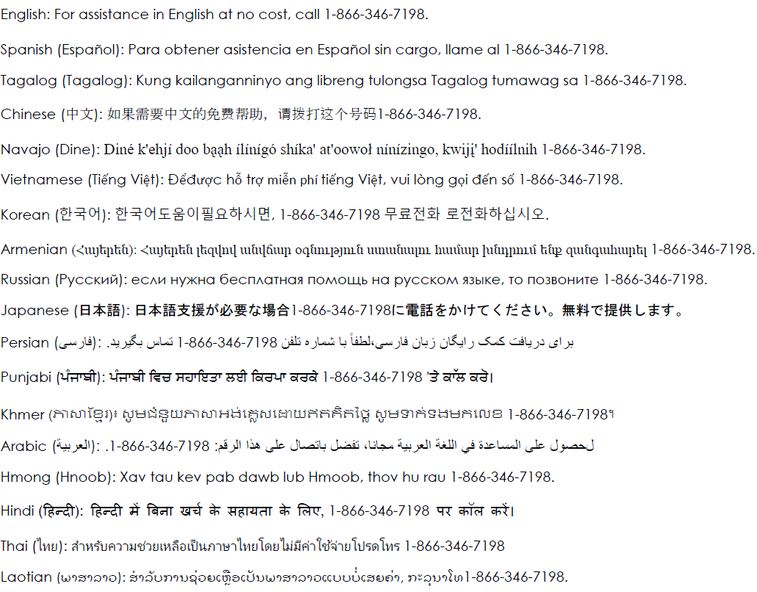
–––––––––––––––––––––To see examples of how this plan might cover costs for a sample medical situation, see the next section.––––––––––––––––––––––
PRA Disclosure Statement
According to the Paperwork Reduction Act of 1995, no persons are required to respond to a collection of information unless it displays a valid OMB control number. The valid OMB control number for this information collection is 0938-1146. The time required to complete this information collection is estimated to average 0.08 hours per response, including the time to review instructions, search existing data resources, gather the data needed, and complete and review the information collection. If you have comments concerning the accuracy of the time estimate(s) or suggestions for improving this form, please write to: CMS, 7500 Security Boulevard, Attn: PRA Reports Clearance Officer, Mail Stop C4-26-05, Baltimore, Maryland 21244-1850.

This is not a cost estimator. Treatments shown are just examples of how this plan might cover medical care. Your actual costs will be different depending on the actual care you receive, the prices your providers charge, and many other factors. Focus on the cost sharing amounts (deductibles, copayments and coinsurance) and excluded services under the plan. Use this information to compare the portion of costs you might pay under different health plans. Please note these coverage examples are based on self-only coverage.
About these Coverage Examples:

Peg is Having a Baby
(9 months of participating pre-natal care and a hospital delivery)

The plan’s overall deductible $1,500
Specialist copayment $50
Hospital (facility) copay+coins $250+30%
Other coinsurance 30%

This EXAMPLE event includes services like:
Specialist office visits (prenatal care)
Childbirth/Delivery Professional Services
Childbirth/Delivery Facility Services
Diagnostic tests (ultrasounds and blood work)
Specialist visit (anesthesia)

Total Example Cost | $12,700

In this example, Peg would pay:
Cost Sharing
Deductibles | $1,500
Copayments | $300
Coinsurance | $3,300
What isn’t covered
Limits or exclusions | $70
The total Peg would pay is | $5,200

Managing Joe’s Type 2 Diabetes
(a year of routine participating care of a well-controlled condition)

The plan’s overall deductible $1,500
Specialist copayment $50
Hospital (facility) copay+coins $250+30%
Other coinsurance 30%

This EXAMPLE event includes services like:
Primary care physician office visits (including disease education)
Diagnostic tests (blood work)
Prescription drugs
Durable medical equipment (glucose meter)

Total Example Cost | $5,600

In this example, Joe would pay:
Cost Sharing
Deductibles | $800
Copayments | $400
Coinsurance | $40
What isn’t covered
Limits or exclusions | $3,500
The total Joe would pay is | $4,700

Mia’s Simple Fracture
(participating emergency room visit and follow up care)

The plan’s overall deductible $1,500
Specialist copayment $50
Hospital (facility) copay+coins $250+30%
Other coinsurance 30%

This EXAMPLE event includes services like:
Emergency room care (including medical supplies)
Diagnostic test (x-ray)
Durable medical equipment (crutches)
Rehabilitation services (physical therapy)

Total Example Cost | $2,800

In this example, Mia would pay:
Cost Sharing
Deductibles | $1,500
Copayments | $40
Coinsurance | $400
What isn’t covered
Limits or exclusions | $10
The total Mia would pay is | $2,000

NONDISCRIMINATION NOTICE
Discrimination is against the law. Blue Shield of California complies with federal civil rights laws and does not discriminate on the basis of race, color, national origin, age, disability, or sex. Blue Shield of California does not exclude people or treat them differently because of race, color, national origin, age, disability, or sex.
Blue Shield of California provides:
- Aids and services at no cost to people with disabilities to communicate effectively with us, such as:
ú Qualified sign language interpreters
ú Written information in other formats (large print, audio, accessible electronic formats, other formats)
- Language services at no cost to people whose primary language is not English, such as:
ú Qualified interpreters
ú Information written in other languages
If you need these services, contact the Blue Shield of California Civil Rights Coordinator.
If you believe that Blue Shield of California has failed to provide these services or discriminated in another way on the basis of race, color, national origin, age, disability, or sex you can file a grievance with:
Blue Shield of California Civil Rights Coordinator
P.O. Box 629007
El Dorado Hills, CA 95762-9007
Phone: (844) 831-4133 (TTY: 711)
Fax: (844) 696-6070
Email: BlueShieldCivilRightsCoordinator@blueshieldca.com
You can file a grievance in person or by mail, fax, or email. If you need help filing a grievance, the Civil Rights Coordinator is available to help you.
You can also file a civil rights complaint with the U.S. Department of Health and Human Services, Office for Civil Rights, electronically through the Office for Civil Rights Complaint Portal, available at https://ocrportal.hhs.gov/ocr/portal/lobby.jsf, or by mail or phone at:
U.S. Department of Health and Human Services
200 Independence Avenue, SW
Room 509F, HHH Building Washington, D.C. 20201
1-800-368-1019, 800-537-7697 (TDD)
Complaint forms are available at http://www.hhs.gov/ocr/office/file/index.html.

